EXP. NO: 18
MATLAB SIMULATION AND EVALUATION OF EYE DIAGRAM PARAMETERS UNDER INTER-SYMBOL INTERFERENCE IN DIGITAL COMMUNICATION SYSTEMS
Objectives :
1. To simulate a digital communication system in MATLAB and generate the eye diagram of the received signal for evaluating eye height, eye width, eye-crossing level and timing margin.
2. To introduce and study Inter-Symbol Interference (ISI) under different channel conditions, and evaluate its effect on eye-diagram opening and overall digital signal quality.
Procedure :
1. Open MATLAB and create a new script file.
2. Define the simulation parameters, including the number of bits and samples per symbol.
3. Generate a random binary data sequence using the randi() function.
4. Encode the binary data into an NRZ (Non-Return-to-Zero) digital signal using the repelem() function.
5. Create a communication channel model by defining a low-pass FIR filter to introduce Inter Symbol Interference (ISI).
6. Pass the transmitted NRZ signal through the channel using the conv() function to obtain the received signal affected by ISI.
7. Generate a time axis for displaying the transmitted and received waveforms.
8. Plot the following signals using MATLAB:
• Original Binary Data
• Transmitted NRZ Signal
• Received Signal with ISI
9. Plot the eye diagram of the received signal using the eyediagram() function.
10. Observe the effect of ISI on the eye diagram by analyzing the eye opening, eye height, eye width, and timing jitter.
11. Interpret the eye diagram to evaluate the performance of the digital communication system under the influence of Inter-Symbol Interference.
12. Record the observations and draw conclusions regarding the impact of ISI on signal quality and communication system performance.
PROGRAM :
clc;
clear;
close all;
%% Parameters
N = 100;
% Number of bits sps = 20;
% Samples per symbol
%% Generate Random Binary Data
data = randi([0 1],1,N);
%% NRZ Encoding
tx = repelem(data,sps);
%% Time Axis
t = (0:length(tx)-1)/sps;
%% Introduce Inter-Symbol Interference (ISI)%
% Simple Low-Pass FIR Filter (Channel)%
h = [0.2 0.6 1 0.6 0.2];
% Received Signal with ISI
rx = conv(tx,h,'same');
%% Plot Results%%
figure;
subplot(4,1,1)
stairs(data,'LineWidth',1.5)
grid on
title('Original Binary Data')
xlabel('Bit Number')
ylabel('Bit')
ylim([-0.2 1.2])
subplot(4,1,2)
plot(t,tx,'LineWidth',1.5)
grid on
title('Transmitted NRZ Signal')
xlabel('Time')
ylabel('Amplitude')
ylim([-0.5 1.5])
subplot(4,1,3)
plot(t,rx,'r','LineWidth',1.2)
grid on
title('Received Signal with Inter-Symbol Interference (ISI)')
xlabel('Time')
ylabel('Amplitude')
subplot(4,1,4)
eyediagram(rx,2*sps)
title('Eye Diagram under ISI')
Output:
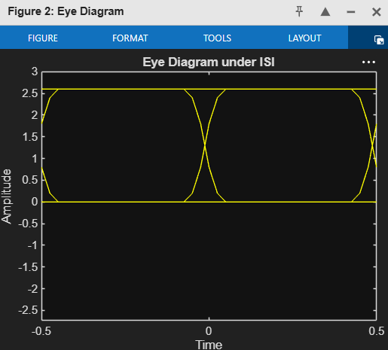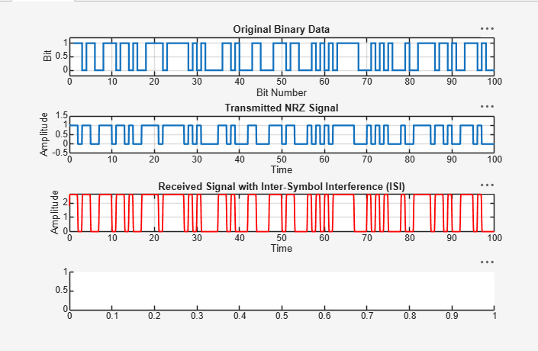
Result:
- Successfully generated an NRZ digital communication signal and transmitted it through a channel introducing Inter-Symbol Interference (ISI). The received signal exhibited pulse spreading and waveform distortion due to ISI, demonstrating its effect on signal quality.
- ii) Successfully plotted and analyzed the eye diagram of the received signal. The reduced eye opening, decreased eye height and eye width, and increased timing jitter confirmed the degradation in communication system performance caused by Inter-Symbol Interference (ISI).

